Microchip TCP/IP Stack Release Notes:
BETA v[6.00] [31 March 2012]

Introduction

The v6.xx version of the MCHP TCP/IP stack addresses the networking applications that need to run with:
- IPv6 support
- Multiple network interfaces support
- Capability to stop/start a network interface or the whole stack dynamically at run time
- PIC32 or PIC24/dsPIC processors that have at least 192-256 KB of flash memory and 16 KB RAM available.

This is the new MCHP TCP/IP stack and it should be used for all the new projects on PIC32 and PIC24/dsPIC machines.
Please note that this current version no longer supports PIC18 processors.
For applications and projects that need PIC18 support or simply do not need IPv6 or multiple network interfaces the MCHP TCP/IP stack v5.41 is still a viable solution.

The following release notes are relevant to the new features added to the version v6.xx of the TCP/IP stack.
For the vast majority of the TCP/IP related issues the regular help file distributed with MCHP MLA is still valid and should be consulted as a source as information.

Demos Provided

Project Description
Included are 14 demos:
- tcpip\tcpip_web_server_demo_app\
  - tcpip_c30_e16_enc28_mrf24w_web_server_demo_app
  - tcpip_c30_e16_enc28_web_server_demo_app
  - tcpip_c30_e16_enc624_mrf24w_web_server_demo_app
  - tcpip_c30_e16_enc624_web_server_demo_app
  - tcpip_c30_e16_mrf24wb_web_server_demo_app
  - tcpip_pic32_e16_enc624_iperf_demo_app
  - tcpip_pic32_e16_enc624_web_server_demo_app
  - tcpip_pic32_e16_mrf24wb_web_server_demo_app
  - tcpip_pic32_esk_iperf_demo_app
  - tcpip_pic32_esk_web_server_demo_app
  - tcpip_pic32_meb_web_server_demo_app
  - tcpip_pic32_usk_enc28_web_server_demo_app
  - tcpip_pic32_usk_enc624_web_server_demo_app
- tcpip\tcpip_web_server_demo_app_ipv6\
  - tcpip_pic32_meb_web_server_demo_app_ipv6

Demo naming conventions are organized as follows:
tcpip_COMPILER_BOARD_INTERFACE1_INTERFACE2_NAME.TYPE
- COMPILER: Type of compiler used
  - C30
  - PIC32 (C32)
- BOARD: Board compatible with project
  - e16 (Explorer 16 - DM240001)
  - esk (Ethernet Starter Kit)
  - meb (Multimedia Expansion Board)
- INTERFACE1: Interface implemented in demo
  - enc28 (Ethernet PICtail Plus Daughter Board (AC164123) with ENC28J60)
  - enc624 (Fast 100Mbps Ethernet PICtail Plus Daughter Board (AC164132) with ENC624J600)
  - mrf24w (MRF24WB0MA Wi-Fi radio transceiver module)
  - Internal PIC32 100 Mbps interface (PIC32 ESK, PIC32 MEB)
- INTERFACE2: Optional interface implemented in demo
  - Same as INTERFACE1 (above)
- NAME: Name of project
  - web_server_demo_app (web server app)
  - iperf_demo_app (network performance measurement app )
- TYPE
  - mcp (MPLAB 8 Project)
  - X (MPLAB X Project)

Project Settings
How to Access Project (Compiler & Linker) Settings:
- MPLAB 8
  - Double click .mcp file to open project
  - Right click on the project name and select “Build Options”
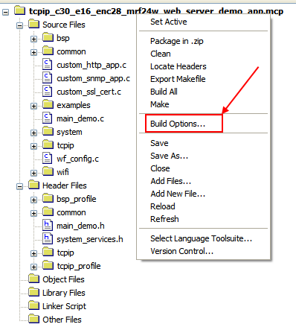
If you do not see the pane above in your IDE select View > Project
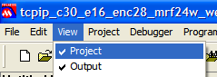
  - Next click on the compiler tab “MPLAB CXX”
This is where the settings for the compiler are configured
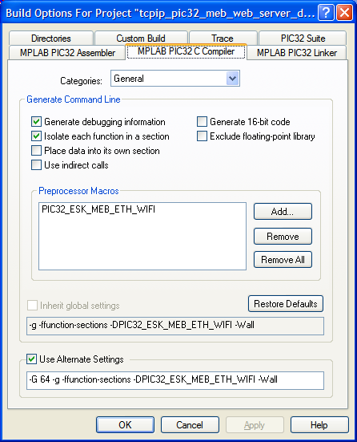
  - Finally click on the linker tab
This is where the settings for the linker are configured
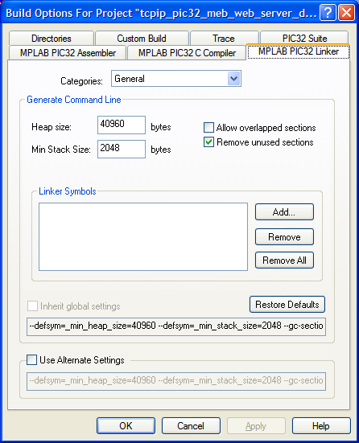
- MPLAB X
  - Start MPLAB X
  - Right click your project in the “Projects” window and select Properties
If you do not see the “Projects” window select Window > Projects or press CTRL + 1
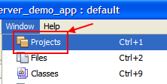
If can see the “Projects” window but do not see your project select File > Open Project… then browse to find your project
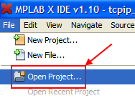
  - Inside the Properties window navigate to Conf: [default] > CXX (Global Options) > picXX-gcc
This is where the settings for the compiler are configured
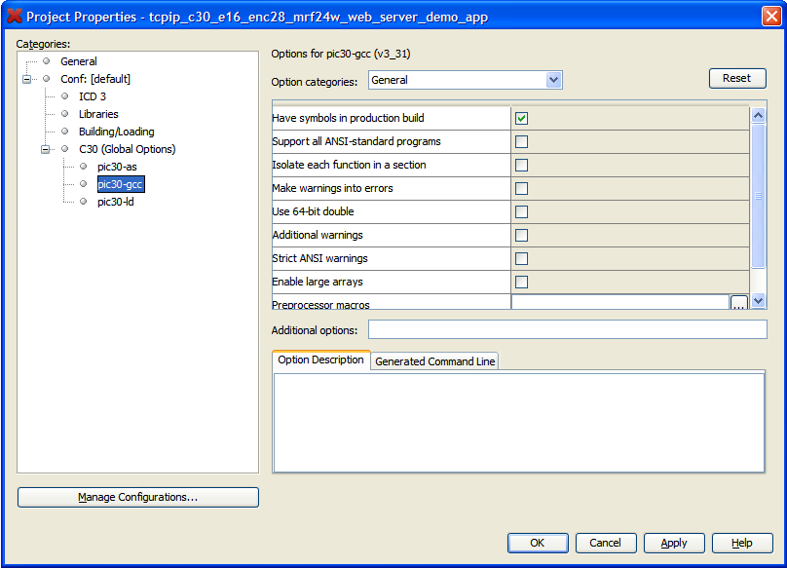
  - Finally navigate to Conf: [default] > CXX (Global Options) > picXX-ld
This is where the settings for the linker are configured
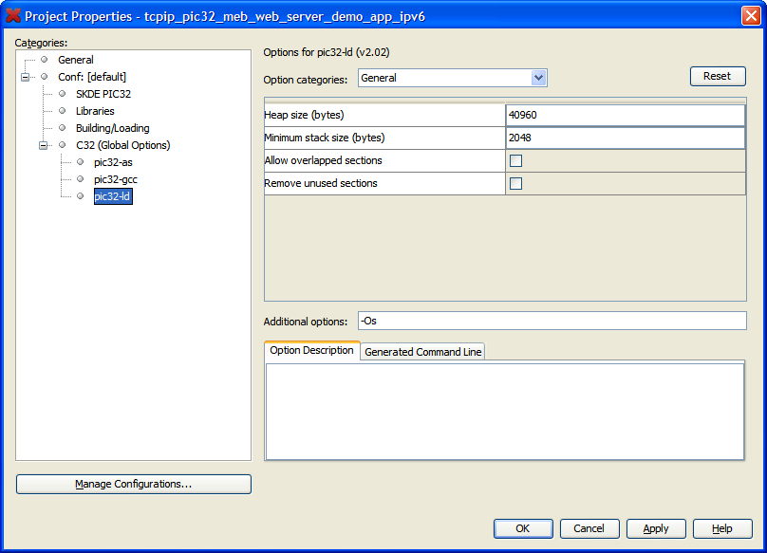

Boards Used / Supported Platforms
For now the supported hardware platforms are as follows:
- PIC32:
  - Multimedia Expansion Board –MEB (DM320005) that supports both an internal 100 Mbps wired Ethernet and a WiFi network interface.
  - PIC32 ESK (DM320004) that runs on the internal 100 Mbps wired PIC32 Ethernet interface.
  - PIC32 USB Starter Kit (DM320001) that can be connected to Ethernet or WiFi PICtails (ENC28J60, ENC624J600, MRF24WB0M) by using an I/O expansion board (DM320002).
  - Explorer 16 board (DM240001) with Ethernet of WiFi PICtails (ENC28J60, ENC624J600, MRF24WB0M)
- PIC24/dsPIC (PIC24FJ256GB110, dsPIC33FJ256GP710)
  - Note: The exact list of all supported devices will be added.
  - Explorer 16 board (DM240001) with Ethernet of WiFi PICtails (ENC28J60, ENC624J600: AC164132, MRF24WB0M: AC164136-4)

Discovering the Board
“The Announce module provides an easy way to determine useful parameters for your TCP/IP node’s interfaces. This module works in conjunction with the TCP/IP Discoverer PC Utility to display an interface’s MAC and IPv4/IPv6 addresses, IPv6 multicast listeners, NBNS host name, and MAC type. During stack operation several events may cause an Announce packet to be broadcast on a particular interface. These include:

- Reception of an Announce packet request on that interface.
- A DHCP event on that interface (i.e. the interface has configured a new IPv4 address using DHCP).
- The addition or removal of an IPv6 Unicast Address from an interface (after Duplicate Address Detection).
- The addition or removal of an IPv6 Multicast Listener from an interface.
- A user call to the ANNOUNCE_Notify() function specifying the interface you want to send parameters for.

Each Announce packet is a UDP packet broadcast from the corresponding interface’s IPv4 address. The payload is a series of fields beginning with an 8-bit field ID, followed by field information, followed by a field terminator (0x0D 0x0A). The current field ID’s and information formats are:

- 0x01 – This field ID indicates that not all of the interface’s address information could be transmitted in one packet. There is no field information for this ID.
  - 0x01 0x0A 0x0D
- 0x02 – MAC address (6 bytes).
  - 0x02 0x00 0x04 0xA3 0x12 0x0f 0x94 0x0D 0x0A
- 0x03 – MAC type. The field information for this ID is a variable length string describing the MAC type of this interface – “ENCJ60”, “ENCJ600”, “97J60”, “PIC32INT”, “MRF24W”.
  - 0x03 ‘P’ ‘I’ ‘C’ ‘3’ ‘2’ ‘I’ ‘N’ ‘T’ 0x0D 0x0A
- 0x04 – Host name. The NBNS host name of the interface, with trailing spaces.
  - 0x04 ‘M’ ‘C’ ‘H’ ‘P’ ‘B’ ‘O’ ‘A’ ‘R’ ‘D’ ‘ ‘ ‘ ‘ ‘ ‘ ‘ ‘ ‘ ‘ ‘ ‘ ‘ ‘ 0x0D 0x0A
- 0x05 – The interface’s IPv4 address (4 bytes, big-endian).
  - 0x05 0x0A 0x00 0x01 0x03 0x0D 0x0A
- 0x06 – One of the interfaces IPv6 unicast addresses (16 bytes, big-endian). Note that the interface may have more than one of these. The interface also has a corresponding solicited-node multicast address listener for every unicast address that is given.
  - 0x06 0xFE 0x80 0x00 0x00 0x00 0x00 0x00 0x00 0x02 0x04 0xA3 0xFF 0xFE 0x12 0x0F 0x94 0x0D 0x0A
- 0x07 – One of the interface’s IPv6 multicast address listeners (16 bytes, big-endian). The solicited-node multicast address listeners will not be included.
  - 0x07 0xFF 0x02 0x00 0x00 0x00 0x00 0x00 0x00 0x00 0x00 0x00 0x00 0x00 0x00 0x00 0x01 0x0D 0x0A

Useful APIs:

- void ANNOUNCE_Notify(TCPIP_NET_HANDLE hNet, uint8_t evType, const void * param)
  - Description: Indicates to the Announce module that an Announce packet should be sent from an interface.
  - Precondition: None.
  - Parameters:
    - hNet – net handle of the interface on which to send an Announce packet.
    - evType – The event type that triggered the Announce message. This field is currently unused, but is included to provide compatiblity with the DHCP-layer and IP-layer event notification registration functions.
    - param – Pointer to additional parameters information relating to the Announce event. This field is currently unused, but is included to provide compatibility with the DHCP-layer and IP-layer event notification registration functions.
  - Returns: void.
  - Remarks:
    - It is possible for this function to fail. When it is called, this function will try to dynamically allocate a structure on the heap to store the hNet and evType parameters until the Announce task function can successfully send an Announce packet. If your stack implementation has used all of the heap when this function is called, it will not be able to save these parameters and will not send an Announce packet. This problem should be solved by allocating additional memory to the heap during production.

The Microchip TCPIP Discoverer PC project will aid in embedded product device discovery (with the Announce protocol) and will demonstrate how to write PC applications to communicate to embedded devices.
When the "Discover Devices" button is clicked, this application will transmit a broadcast UDP packet containing the message, "Discovery: Who is out there?" on the local network to port 30303. If any embedded devices with the Announce protocol enabled are connected to the network, they will respond with a UDP packet containing their MAC address, MAC type(Interface Type), host name (NBNS), IPv4/IPv6 addresses and IPv6 multicast Listeners. Each information of this UDP packet is displayed as set of hierarchical data( JTree Class) .”Devices” is represented as root node and each MAC-Address of the UDP packet is represented as the child node and other payload information of the UDP data are child node to the MAC-Address node.
“Truncated” string is added as child node to the MAC-Address node, if the Announce UDP packet payload has not enough space to contain interface details.
If TCPIP_STACK_USE_HTTP2_SERVER is enabled, then double click on MAC-Address node, http://ipv4address client will communicate with web server module of the device.
The Java source code for this application is also included. This source code should provide a rough idea of how to write a PC-based application to communicate with your embedded devices.

Configuring your Application
The configurations for your applications are stored in its corresponding tcpip_profile and bsp_profile directories.

Module specific configurations are stored in the within the “configs” folder which can be found in the same directory as the application. The configs folder is broken up by board. After selecting the board you can edit Module or Board Specific Configurations.

Module Specific Configurations:
The tcpip_profile directory stores configuration files broken up by module. Each configuration file has been appended with the name of the module it represents (examples below).
- tcpip\application_name\configs\board\tcp_profile
  - dns_config.h
  - ftp_config.h
  - tcpip_config.h
  - MODULE_config.h

Board Specific Configurations:
The bsp_profile directory stores configuration folders broken up by interface. Each interface folder contains 3 configuration files.
- tcpip\application_name\configs\board\bsp_profile\interface
  - hardware_profile.h – Contains hardware specific definition
      - LEDs
      - Buttons
      - …
  - network_profile.h – Contains stack network configuration options.
      - Interface
      - Host Name
      - Address
      - …
  - system_profile.h – Contains important configuration definitions for the system
      - System Ticks per Second
      - Debugging Enabler
      - Consol Enable
      - …

System Services
- The stack is regarded as being part of a greater application that is managed by some system layer that provides services (timer and interrupt functions, drivers, etc). Therefore the stack uses the system services for accessing common shared resources across the system.
  - Initialization and system maintenance services - SYS_Initialize, SYS_Reboot, SYS_WDT_Clear
    - SYS_Initialize is calling the BSP_Initialize routine that performs the actual board initialization
  - Clock services - SYS_CLK_ClockGet, SYS_CLK_PeripheralClockGet, SYS_CLK_OscClockGet
  - System Tick/Time services - SYS_TICK_Get, SYS_TICK_ResolutionGet, SYS_TICK_TicksPerSecondGet, SYS_TICK_HwResolutionGet, SYS_TICK_HwCountGet
  - System timer services - SYS_TICK_TimerCreate, SYS_TICK_TimerDelete, SYS_TICK_TimerSetRate
  - System interrupt services - SYS_INT_SourceEnable, SYS_INT_SourceDisable, SYS_INT_SourceRestore, SYS_INT_SourceStatusClear, SYS_INT_PrioritySet
  - Dynamic system interrupt services - SYS_INT_DynamicRegister
  - System dynamic memory services – SystemMalloc, SystemCalloc, SystemFree
  - Please see the microchip/include/system/system_services.h for details.
- A system console and debugging services have been added as part of system_debug.h. The TCP/IP stack makes use of these services and no longer manipulates directly peripherals that it doesn’t own (like UARTs, SPI’s, etc). This service provides:
  - Error and debug services - SYS_ASSERT, SYS_ERROR, SYS_ERROR_PRINT
  - System console services - SYS_CONSOLE_MESSAGE, SYS_CONSOLE_PRINT, SYS_CONSOLE_DATA_RDY, SYS_CONSOLE_GETC, SYS_CONSOLE_PUTC, SYS_CONSOLE_KBHIT, SYS_CONSOLE_GETLINE, SYS_CONSOLE_SCANF
  - System output services (a system output channel can be one like an LCD, for example) - SYS_OUT_MESSAGE, SYS_OUT_MESSAGE_LINE, SYS_OUT_MESSAGE_OFFSET, SYS_OUT_MESSAGE_LINE_COUNT, SYS_OUT_MESSAGE_LINE_LENGTH.
  - Please see the microchip/include/system/system_debug.h for more details.
- Known Issues
  - The system services include drivers for UART, SPI, lfsr, hashes, etc; File system and others have not been ported yet and are still part of the stack.

Directory structure
The current directory structure of the MCHP TCP/IP stack is presented below:

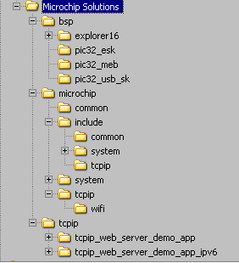

The following directories are relevant:
- tcpip: Contains the demos supplied with the TCP/IP stack.
- bsp: Contains the Board support package files
- microchip: Contains the files that implement the stack

SW License Agreement
MICROCHIP IS WILLING TO LICENSE THE ACCOMPANYING SOFTWARE AND DOCUMENTATION TO YOU ONLY ON THE CONDITION THAT YOU ACCEPT ALL OF THE FOLLOWING TERMS. TO ACCEPT THE TERMS OF THIS LICENSE, CLICK "I ACCEPT" AND PROCEED WITH THE DOWNLOAD OR INSTALL. IF YOU DO NOT ACCEPT THESE LICENSE TERMS, CLICK "I DO NOT ACCEPT," AND DO NOT DOWNLOAD OR INSTALL THIS SOFTWARE.

NON-EXCLUSIVE SOFTWARE LICENSE AGREEMENT

This Nonexclusive Software License Agreement ("Agreement") is a contract between you, your heirs, successors and assigns ("Licensee") and Microchip Technology Incorporated, a Delaware corporation, with a principal place of business at 2355 W. Chandler Blvd., Chandler, AZ 85224-6199, and its subsidiary, Microchip Technology (Barbados) II Incorporated (collectively, "Microchip") for the accompanying Microchip software including, but not limited to, Graphics Library Software, IrDA Stack Software, MCHPFSUSB Stack Software, Memory Disk Drive File System Software, mTouch(TM) Capacitive Library Software, Smart Card Library Software, TCP/IP Stack Software, MiWi(TM) DE Software, Security Package Software, and/or any PC programs and any updates thereto (collectively, the "Software"), and accompanying documentation, including images and any other graphic resources provided by Microchip ("Documentation").

- Definitions. As used in this Agreement, the following capitalized terms will have the meanings defined below:
  - "Microchip Products" means Microchip microcontrollers and Microchip digital signal controllers.
  - "Licensee Products" means Licensee products that use or incorporate Microchip Products.
  - "Object Code" means the Software computer programming code that is in binary form (including related documentation, if any), and error corrections, improvements, modifications, and updates.
  - "Source Code" means the Software computer programming code that may be printed out or displayed in human readable form (including related programmer comments and documentation, if any), and error corrections, improvements, modifications, and updates.
  - "Third Party" means Licensee’s agents, representatives, consultants, clients, customers, or contract manufacturers.
  - "Third Party Products" means Third Party products that use or incorporate Microchip Products.
- Software License Grant. Microchip grants strictly to Licensee a non-exclusive, non-transferable, worldwide license to:
  - use the Software in connection with Licensee Products and/or Third Party Products;
  - if Source Code is provided, modify the Software; provided that Licensee clearly notifies Third Parties regarding the source of such modifications;
  - distribute the Software to Third Parties for use in Third Party Products, so long as such Third Party agrees to be bound by this Agreement (in writing or by "click to accept") and this Agreement accompanies such distribution;
  - sublicense to a Third Party to use the Software, so long as such Third Party agrees to be bound by this Agreement (in writing or by "click to accept");
  - with respect to the TCP/IP Stack Software, Licensee may port the ENC28J60.c, ENC28J60.h, ENCX24J600.c, and ENCX24J600.h driver source files to a non-Microchip Product used in conjunction with a Microchip ethernet controller;
  - with respect to the MiWi (TM) DE Software, Licensee may only exercise its rights when the Software is embedded on a Microchip Product and used with a Microchip radio frequency transceiver or UBEC UZ2400 radio frequency transceiver which are integrated into Licensee Products or Third Party Products.
For purposes of clarity, Licensee may NOT embed the Software on a non-Microchip Product, except as described in this Section.
- Documentation License Grant. Microchip grants strictly to Licensee a non-exclusive, non-transferable, worldwide license to use the Documentation in support of Licensee's authorized use of the Software
- Third Party Requirements. Licensee acknowledges that it is Licensee’s responsibility to comply with any third party license terms or requirements applicable to the use of such third party software, specifications, systems, or tools. This includes, by way of example but not as a limitation, any standards setting organizations requirements and, particularly with respect to the Security Package Software, local encryption laws and requirements. Microchip is not responsible and will not be held responsible in any manner for Licensee’s failure to comply with such applicable terms or requirements.
- Open Source Components. Notwithstanding the license grant in Section 1 above, Licensee further acknowledges that certain components of the Software may be covered by so-called "open source" software licenses ("Open Source Components"). Open Source Components means any software licenses approved as open source licenses by the Open Source Initiative or any substantially similar licenses, including without limitation any license that, as a condition of distribution of the software licensed under such license, requires that the distributor make the software available in source code format. To the extent required by the licenses covering Open Source Components, the terms of such license will apply in lieu of the terms of this Agreement. To the extent the terms of the licenses applicable to Open Source Components prohibit any of the restrictions in this Agreement with respect to such Open Source Components, such restrictions will not apply to such Open Source Component.
- Licensee Obligations. Licensee will not: (a) engage in unauthorized use, modification, disclosure or distribution of Software or Documentation, or its derivatives; (b) use all or any portion of the Software, Documentation, or its derivatives except in conjunction with Microchip Products, Licensee Products or Third Party Products; or (c) reverse engineer (by disassembly, decompilation or otherwise) Software or any portion thereof. Licensee may not remove or alter any Microchip copyright or other proprietary rights notice posted in any portion of the Software or Documentation. Licensee will defend, indemnify and hold Microchip and its subsidiaries harmless from and against any and all claims, costs, damages, expenses (including reasonable attorney's fees), liabilities, and losses, including without limitation: (x) any claims directly or indirectly arising from or related to the use, modification, disclosure or distribution of the Software, Documentation, or any intellectual property rights related thereto; (y) the use, sale and distribution of Licensee Products or Third Party Products; and (z) breach of this Agreement.
- Confidentiality. Licensee agrees that the Software (including but not limited to the Source Code, Object Code and library files) and its derivatives, Documentation and underlying inventions, algorithms, know-how and ideas relating to the Software and the Documentation are proprietary information belonging to Microchip and its licensors ("Proprietary Information"). Except as expressly and unambiguously allowed herein, Licensee will hold in confidence and not use or disclose any Proprietary Information and will similarly bind its employees and Third Party(ies) in writing. Proprietary Information will not include information that: (i) is in or enters the public domain without breach of this Agreement and through no fault of the receiving party; (ii) the receiving party was legally in possession of prior to receiving it; (iii) the receiving party can demonstrate was developed by the receiving party independently and without use of or reference to the disclosing party's Proprietary Information; or (iv) the receiving party receives from a third party without restriction on disclosure. If Licensee is required to disclose Proprietary Information by law, court order, or government agency, License will give Microchip prompt notice of such requirement in order to allow Microchip to object or limit such disclosure. Licensee agrees that the provisions of this Agreement regarding unauthorized use and nondisclosure of the Software, Documentation and related Proprietary Rights are necessary to protect the legitimate business interests of Microchip and its licensors and that monetary damage alone cannot adequately compensate Microchip or its licensors if such provisions are violated. Licensee, therefore, agrees that if Microchip alleges that Licensee or Third Party has breached or violated such provision then Microchip will have the right to injunctive relief, without the requirement for the posting of a bond, in addition to all other remedies at law or in equity.
- Ownership of Proprietary Rights. Microchip and its licensors retain all right, title and interest in and to the Software and Documentation including, but not limited to all patent, copyright, trade secret and other intellectual property rights in the Software, Documentation, and underlying technology and all copies and derivative works thereof (by whomever produced). Licensee and Third Party use of such modifications and derivatives is limited to the license rights described in this Agreement.
- Termination of Agreement. Without prejudice to any other rights, this Agreement terminates immediately, without notice by Microchip, upon a failure by Licensee or Third Party to comply with any provision of this Agreement. Upon termination, Licensee and Third Party will immediately stop using the Software, Documentation, and derivatives thereof, and immediately destroy all such copies.
- Warranty Disclaimers. THE SOFTWARE AND DOCUMENTATION ARE PROVIDED "AS IS" WITHOUT WARRANTY OF ANY KIND, EITHER EXPRESS OR IMPLIED, INCLUDING WITHOUT LIMITATION, ANY WARRANTY OF MERCHANTABILITY, TITLE, NON-INFRINGEMENT AND FITNESS FOR A PARTICULAR PURPOSE. MICROCHIP AND ITS LICENSORS ASSUME NO RESPONSIBILITY FOR THE ACCURACY, RELIABILITY OR APPLICATION OF THE SOFTWARE OR DOCUMENTATION. MICROCHIP AND ITS LICENSORS DO NOT WARRANT THAT THE SOFTWARE WILL MEET REQUIREMENTS OF LICENSEE OR THIRD PARTY, BE UNINTERRUPTED OR ERROR-FREE. MICROCHIP AND ITS LICENSORS HAVE NO OBLIGATION TO CORRECT ANY DEFECTS IN THE SOFTWARE.
- Limited Liability. IN NO EVENT WILL MICROCHIP OR ITS LICENSORS BE LIABLE OR OBLIGATED UNDER ANY LEGAL OR EQUITABLE THEORY FOR ANY DIRECT OR INDIRECT DAMAGES OR EXPENSES INCLUDING BUT NOT LIMITED TO INCIDENTAL, SPECIAL, INDIRECT, PUNITIVE OR CONSEQUENTIAL DAMAGES, LOST PROFITS OR LOST DATA, COST OF PROCUREMENT OF SUBSTITUTE GOODS, TECHNOLOGY, SERVICES, OR ANY CLAIMS BY THIRD PARTIES (INCLUDING BUT NOT LIMITED TO ANY DEFENSE THEREOF), OR OTHER SIMILAR COSTS. The aggregate and cumulative liability of Microchip and its licensors for damages hereunder will in no event exceed $1000 or the amount Licensee paid Microchip for the Software and Documentation, whichever is greater. Licensee acknowledges that the foregoing limitations are reasonable and an essential part of this Agreement.
- General. THIS AGREEMENT WILL BE GOVERNED BY AND CONSTRUED UNDER THE LAWS OF THE STATE OF ARIZONA AND THE UNITED STATES WITHOUT REGARD TO CONFLICTS OF LAWS PROVISIONS. Licensee agrees that any disputes arising out of or related to this Agreement, Software or Documentation will be brought exclusively in either the U.S. District Court for the District of Arizona, Phoenix Division, or the Superior Court of Arizona located in Maricopa County, Arizona. This Agreement will constitute the entire agreement between the parties with respect to the subject matter hereof. It will not be modified except by a written agreement signed by an authorized representative of Microchip. If any provision of this Agreement will be held by a court of competent jurisdiction to be illegal, invalid or unenforceable, that provision will be limited or eliminated to the minimum extent necessary so that this Agreement will otherwise remain in full force and effect and enforceable. No waiver of any breach of any provision of this Agreement will constitute a waiver of any prior, concurrent or subsequent breach of the same or any other provisions hereof, and no waiver will be effective unless made in writing and signed by an authorized representative of the waiving party. Licensee agrees to comply with all import and export laws and restrictions and regulations of the Department of Commerce or other United States or foreign agency or authority. The indemnities, obligations of confidentiality, and limitations on liability described herein, and any right of action for breach of this Agreement prior to termination, will survive any termination of this Agreement. Any prohibited assignment will be null and void. Use, duplication or disclosure by the United States Government is subject to restrictions set forth in subparagraphs (a) through (d) of the Commercial Computer-Restricted Rights clause of FAR 52.227-19 when applicable, or in subparagraph (c)(1)(ii) of the Rights in Technical Data and Computer Software clause at DFARS 252.227-7013, and in similar clauses in the NASA FAR Supplement. Contractor/manufacturer is Microchip Technology Inc., 2355 W. Chandler Blvd., Chandler, AZ 85224-6199.

If Licensee has any questions about this Agreement, please write to Microchip Technology Inc., 2355 W. Chandler Blvd., Chandler, AZ 85224-6199 USA. ATTN: Marketing.

Copyright (c) 2012 Microchip Technology Inc. All rights reserved.

License Rev. No. 05-012412

Release Notes

This is a major release and a lot of features have been added and a lot of things have been changed.

Project changes:
- Projects now use a specific configuration directory for the board and processor that they are supposed to run for.
- All the configurations are stores in the “configs” directory that’s at the same level. This directory contains configuration files for:
  - BSP
  - Network
  - System
  - TCPIP
- Just point your project include path to the right configuration directory in order to build/run the project on a specific board/part.

General TCP/IP features:
- Changes/updates:
  - The file naming convention has changed. All the files names use now lower case and an underscore as delimiter
  - The microchip/include/tcpip directory contains now only public interface header files. All the private header files were moved to the microchip/tcpip source directory.
  - The stack initialization function has changed. The new function is called TCPIP_STACK_Init() and takes parameters that specify the network settings per interface and stack module configuration data.
  - The stack support dynamic initialization. When the stack is initialized each module receives its configuration data as a parameter.
  - Build time #defines will eventually be used only for major functionality/blocks that are to be part or not of the build.
  - The intent is to have the TCP/IP stack build and run as a library that can be used by any application that needs it.
  - The stack support now dynamic interface up and down functions: TCPIP_STACK_NetUp, TCPIP_STACK_NetDown. You can shut down an interface at run time and then restart it providing network configuration parameters. Please note that you cannot re-configure the stack modules by using an If down/If up operation. You need to de-initialize the stack for this.
  - In order to get info about an interface a handle has to be obtained. By using TCPIP_STACK_NetHandle
  - A lot of new functions were added for control and access to the private setting of the network interfaces using a handle to access a specific interface. Please see microchip/include/tcpip_tcpip_manager.h for details.
  - The stack supports notification events. The user can select what events he needs to be notified of (TCPIP_STACK_SetNotifyEvents, TCPIP_STACK_ClearNotifyEvents) and can register a handler using TCPIP_STACK_SetNotifyHandler. Whenever an event occurs the notification handler will be called. Even without a handler the TCPIP_STACK_GetPending can be called to get a snapshot of the current pending events. See the microchip/include/tcpip/tcpip_events.h for details. The supported events are:
    - RX events (TCPIP_EV_RX_PKTPEND, TCPIP_EV_RX_OVFLOW, TCPIP_EV_RX_BUFNA, TCPIP_EV_RX_ACT, TCPIP_EV_RX_DONE, TCPIP_EV_RX_FWMARK, TCPIP_EV_RX_EWMARK, TCPIP_EV_RX_BUSERR
    - TX events (TCPIP_EV_TX_DONE, TCPIP_EV_TX_ABORT, TCPIP_EV_TX_BUSERR)
    - Connection events (TCPIP_EV_CONN_ESTABLISHED, TCPIP_EV_CONN_LOST).
    - Please note that not all network interfaces support all types of events.
    - The connection events are triggered not by the hardware but by the TCPIP manager which constantly monitors the link status. This is to allow connection events even on platforms that do not use a physical interrupt line to report the PHY connection lost status (PIC32 mainly).

  - The stack is regarded as being part of a greater application that is managed by some system layer that provides services (timer and interrupt functions, drivers, etc). Therefore the stack uses the system services for accessing common shared resources across the system. (See System Services)
  - A system console and debugging services have been added as part of system_debug.h. The TCP/IP stack makes use of these services and no longer manipulates directly peripherals that it doesn’t own (like UARTs, SPI’s, etc). (See System Services)
  - The stack uses now dynamic memory allocation functions. It has its own fast memory allocator and creates its own heap in a block of memory that’s provided as part of the initialization. The size of this heap is specified by the tcpip_config.h:: TCPIP_STACK_DRAM_SIZE parameter. Please note that this parameter is highly configurable depending on the number and type of supported MACs, number of TCP/UDP/HTTP/SSL/etc. connections. For a PIC32 build it should be at least 8KB in size. For a 16 bit build it should be at least 4 KB.
  - A TCPIP storage service has been added. It allows a stack client to initialize a storage with TCPIP_STORAGE_Init, to get a handle to it with TCPIP_STORAGE_Open and then get entries, set labels, refresh, erase, etc. Please see microchip/include/tcpip/tcpip_storage.h for details.

- Known issues:
  - Not all modules have removed their private definitions from the public API header file.
  - Not all module specific configuration data was created.
  - Notification mechanism does not support multiple clients right now. It can be upgraded if needed.
  - Not all system services and drivers are available yet for all platforms.
  - We’ll be addressing size issues in further releases. We’ll try to reduce the code size that some services take right now.
  - The whole RAM usage should be heap allocation based. This would allow a better control and trim of the allocated resources.

MAC features:
- Changes/updates
  - An enumerated type has been added for all the supported MACs. All the MACs share the same interface but they are initializaed based on the corresponding MAC type.
  - Once a MAC has been initialized a handle to that MAC is obtained by calling MACOpen. From that moment on all access to a MAC is done using that handle.
  - All MAC access functions across the stack have been modified to take a new parameter which is the MAC handle. This is how the stack operates on multiple interfaces simultaneously.
  - MAC initialization and de-initialization can be done dynamically. So that it is consistent with the stack initialization process.
  - The PIC32 internal MAC supports interrupts and event notifications. The design of the stack is event driven and can be easily integrated into an OS environment. The supported notification functions are:
    - MACEventSetNotifyEvents, MACEventClearNotifyEvents, MACEventAck, MACEventGetPending, MACEventSetNotifyHandler.
    - Please note that the MACEventSetNotifyHandler is meant for internal notification and cannot be used by a stack client to be notified of MAC events. The TCPIP_STACK_SetNotifyHandler has to be used for these purposes.

- Known issues
  - The SPI/PMP MACs do not generate proper transfer interrupts for now. This will be addressed as SPI drivers that work in interrupts are available.
  - Low power mode not supported yet on all MACs
  - TCPIP_STACK_Init configuration parameters do not support all MACs
  - WiFi MAC uses a #define instead of the txBuffSize passed as a parameter
  - Buffers on the external MACS will be removed. For now they are still there because some old modules rely on them but support will be removed soon. The MAC buffers should be only used for incoming /outgoing packets.
  - Support for low power mode is there but it has not been implemented yet.

ARP:
- Changes/updates:
  - ARP maintains a local cache per interface now and maintains the information in the cache. The cache itself is implemented with a fast Open Addressing type hash (that supports double hash/linear probing scheme).
  - The number of entries in the cache, the timeouts and other parameters are configurable. See arp_config.h.
  - A complete set of cache entries manipulation functions has been added: ARPEntrySet, ARPEntryGet, ARPEntryRemove, etc. For detail splease see the microchip/include/tcpip/arp.h API file.
  - ARP supports now registration services The ARP client can register an ARP resolve handler. The client will be notified when an ARP event occurred (entry solved/removed, etc.).

- Known issues
  - The ARP query should be quit when a DCP event signals changing of the network/gateway. This is an efficiency improvement.
  - The ARP registration was meant for IP layer purposes only. For this and for saving memory resources a single ARP handler can be registered right now. A more generic registration process (like the one implemented by DHCP, for example) will be implemented.
  - The ARP resolution will be removed form different services throughout the stack. Only one layer (IP) will ask for ARP resolution when it’s needed.

UDP
- Changes/updates:
  - The UDP interface has changed. The preferred API for opening a socket is:
    - UDPOpenClient– for opening a client socket (outgoing connection)
    - UDPOpenServer– for opening a server socket (incoming connection)
  - DNS resolution is no longer performed by the UDP module. It accepts only IP addresses as a source or destination of a transfer. The UDP client has to perform the DNS resolution if it needs to before calling the UDPOpen functions.
  - A function for binding a socket to a local interface have been added (for multi homed hosts): UDPBind.
  - A remote bind function UDPRemoteBind is also provided for server sockets if they need to accept connections only from a specified remote party.
  - A function to allow an UDP socket to send broadcasts has been added UDPSetBcastIPAddress.
  - The selection of a UDP ephemeral port has been improved and is now properly done.
  - UDPOpen has been removed from the stack API. The new UDPOpenServer/UDPOpenClient functions should be used.
  - The byte access functions UDPPut, UDPGet are still maintained for backward compatibility and buffer economy reasons but it should be noted that they are inefficient. UDPPutArray/UDPGetArray usage is preferred.
  - Functions to set/get the working interface for a socket on multi homed hosts have been added UDPSocketSetNet/ UDPSocketGetNet.
  - All UDP functions now take an extra parameter which is the number identifying the UDP socket.
  - Please see microchip/include/tcpip/udp.h for further details.

- Known issues:
  - UDPSetOptions is a function to allow socket options to be set dynamically (like enable broadcast, Rx/Tx buffer size, etc.) It is not implemented yet.
  - UDPBind and UDPRemoteBind should fail if a socket is already bound to an interface. It is not implemented yet. For now if you need it just call bind functions immediately after the socket is created.
  - A full buffered UDP approach is under development. It will allow a socket user a buffer space where the UDP data will be maintained. Right now the UDP data is lost if the user does not claim it immediately.

TCP:
- Changes/updates:
  - The TCP interface has changed. The preferred API for opening a socket is:
    - TCPOpenClient– for opening a client socket (outgoing connection)
    - TCPOpenServer– for opening a server socket (incoming connection)
  - DNS resolution is no longer performed by the TCP module. It accepts only IP addresses as a source or destination of a transfer. The TCP client has to perform the DNS resolution if it needs to before calling the TCPOpenClient/TCPOpenServer functions.
  - A function for binding a socket to a local interface have been added (for multi homed hosts): TCPBind.
  - A remote bind function TCPRemoteBind is also provided for server sockets if they need to accept connections only from a specified remote party.
  - The selection of a TCP ephemeral port has been improved and is now properly done.
  - TCPOpen has been removed from the stack API. The new TCPOpenServer/TCPOpenClient functions should be used.
  - The byte access functions TCPPut, TCPGet are still maintained for backward compatibility and buffer economy reasons but it should be noted that they are inefficient. TCPPutArray/TCPGetArray usage is preferred.
  - Functions to set/get the working interface for a socket on multi homed hosts have been added TCPSocketSetNet/ TCPSocketGetNet.
  - Please see microchip/include/tcpip/tcp.h for further details.

- Known issues:
  - TCPSetOptions is a function to allow socket options to be set dynamically (Rx/Tx buffer size, etc.) It is not implemented yet.
  - TCPBind and TCPRemoteBind should fail if a socket is already bound to an interface. It is not implemented yet. For now if you need it just call bind functions immediately after the socket is created.
  - There are known issues with the TCP state machine (regarding ack and/or sequence numbers). We’re trying to resolve the state machine and the issues will be fixed in the next release.

DHCP:
- Changes/updates:
  - DHCP supports now registration services The DHCP client can register an DHCP event handler. The client will be notified when an DHCP event occurred (discover/bound/expired, etc.). The implementation is fully dynamic so that any number of clients can register (depending on the available memory resources).
  - DHCPStateChanged has been removed as being a not useful API function in a multi threaded environment. Registration handlers should be used.

- Known issues:
  - DHCP initialization data is missing; The DHCP should be enabled/disabled when an interface is initialized.

DNS:
- Changes/updates:

- Known issues:
  - DNS on/off should be added to the TCPIP_STACK_Init and the TCPIP_HOSTS_CONFIGURATION structure.
  - Client registration for DNS events would be nice to have.
  - A proper implementation supporting a cache will be added.
  - DNSBeginUsage and DNSEndUsage will be removed.

BSD:
telnet:

TBD: Add the other services

Not Ported Services:
- Some of the services and protocol layers in the MCHP TCP/IP stack have not been ported to the new v6.xx stack. Some of these protocols are: DHCP server, FTP and TFTP, SNMP and SNMP v3, ZeroConf – Link Local, etc.
We’ll port and update these protocols and integrate them into the v6 stack. Once a protocol is ported/updated we’ll update the Beta package of the stack available on the MCHP web site.
- The utilities that were distributed as part of the MCHP TCP/IP stack MLA release have not been updated for the v6.xx stack. An overview of the tools will be performed and the necessary ones will be maintained, updated and ported to the new stack version.
- Other demos like UART to TCP bridge and uart_config have been removed from the actual version of the stack. They will be added eventually (at least the bridge application) but just as demos that use the TCP/IP stack and not as an integral part of the stack since they don’t rightfully belong in the stack.

Stack Performance
Please note that the TCP/IP stack includes now “iperf” as a standard tool for measuring the stack performance and performing benchmarks.

Please see “iperf Release Notes.docx”

Resources usage

Few examples of typical projects are displayed in the table below.

Project | Major Components | Build | Flash size | RAM size
tcpip_pic32_meb_web_server_demo_app | HTTP, SSL, IPv6, dual interface | -G 64 -g -ffunction-sections -Os, mips32 | 247640 bytes | 19846 bytes RAM + 40960 bytes Heap + 2048 bytes stack
tcpip_pic32_meb_web_server_demo_app | HTTP, SSL, IPv6, dual interface | -G 64 -g -ffunction-sections -Os, mips16 | 187904 bytes | 19690 bytes + 40960 bytes Heap + 2048 bytes stack
tcpip_pic32_e16_enc624_web_server_demo_app | HTTP, SSL, IPv6, single interface | -G 64 -g -ffunction-sections -Os, mips16 | 133500 bytes | 11508 bytes + 14336 bytes Heap + 2048 bytes stack

TBD: Other boards/processors/builds resources will be added.

